Docker image build by Docker Compose and running container from that image on ubuntu
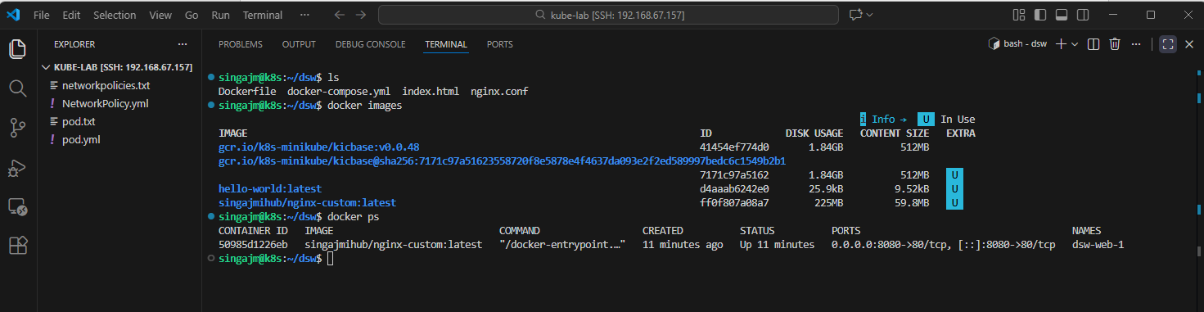
Docker image to the Docker HUB
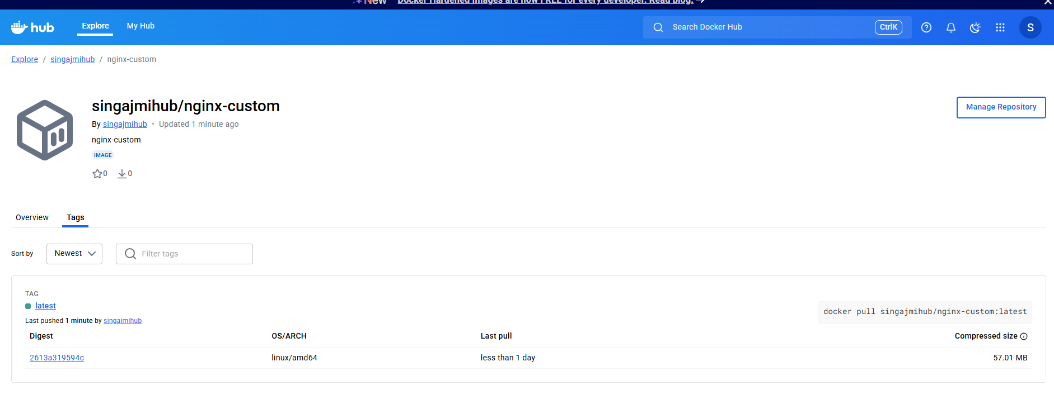
Nginx running image


